Linear Regression in PSPP

PSPP is very similar to SPSS with a few exceptions. This exercise uses PSPP to run a regression on school test scores.

Linear regression, also known as Ordinary Least Squares regression looks at how much of one variable (independent) explains the variation in another variable (dependent)

* Poverty and school test scores
* Demographics and crime

To run a regression in PSPP, go to Analyze | Regression | Linear

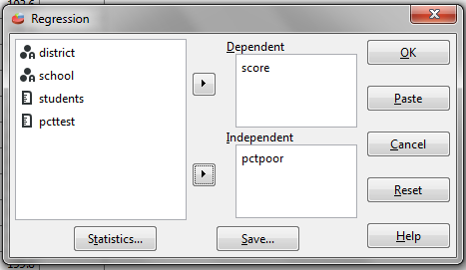

When you run a regression, you get a result called an R-square. That tells you much the independent variable predicts the dependent variable.

83 percent of the variation in test scores is explained by change in poverty

Model

R

R Square

Adjusted R Square

Std. Error of the Estimate

1

.911(a)

.830

.829

10.8330

It also allows you to “adjust” the data or to see if entities are doing better or worse than they should, given the independent variable.

For our test scores example it controls for poverty levels to see if schools are doing better or worse than they should, given their level of poverty.

The Math

The regression calculation is based on the formula for a line: y=mx+b

In our school test score analysis, y is the predicted score, x is the poverty rate, m is the slope of the line (how much a change in poverty explains a change in score). b is the y-intercept – where the line crosses the y axis.

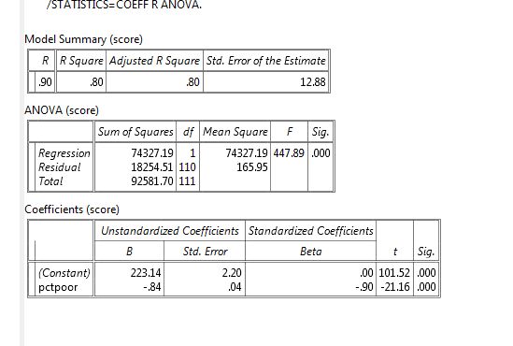

Predicted score=-.84x+223.14

Saving data

In addition to the output, PSPP will save variables to your data.

To do that click Save in your regression and check Predicted values and Residuals.

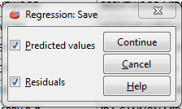

In this case, we’ve saved the Predicted Score (based on the poverty level); the Residual (the difference between the actual and the predicted score) and the Standardized Residual (the number of standard deviations from the mean residual). The Standardized Residual is often used to categorize your data. Say, every school that is more than 2 is doing better than expected. Those with scores of less than -2 are doing worse than expected.

